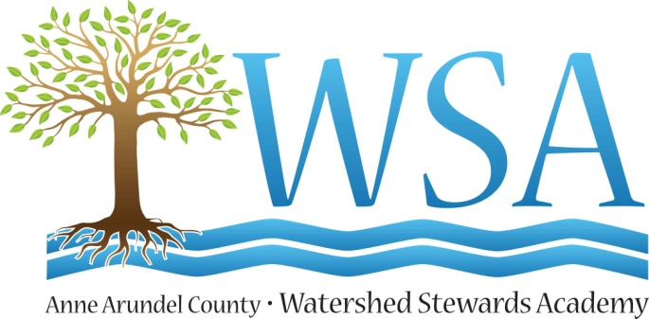

Release of Liability
In exchange for services provided by Anne Arundel County Watershed Stewards Academy (WSA), for the purposes of educating and demonstrating stormwater runoff reduction methods, I , the legal property owner and/or manager of _________________(address), agree for myself and (if applicable) my family to the following:
- I agree to permit WSA planned activities at my property, for my benefit and without reservations, to allow the initial assessment of these stormwater concerns as well as any work performed by any WSA members, associates and volunteers.
- I recognize there are some risks associated with the above described activities and I further release and discharge WSA for injury, loss or damages resulting from these activities.
- I agree to indemnify and hold harmless WSA, its members, associates and volunteers of any and all future claims which may arise from this activity and if any changes or alteration are made to this project by myself or family, these modifications will not, in any way, be associated with WSA.
I have read this document and understand it. I further understand that by signing this release, I voluntarily surrender certain legal rights.

Dated: ___________________________
Signature:____________________________________
Name(print): _______________________________________
Site Address:__________________________________

